**Practical File**

***Lab Name : Computer Organization And Architecture Lab***

***Lab Code : KCS-352***

**Name : Samarpit Dua**

**Roll no. : 1900321290050**

**Branch : CEIT**

**Course : B.Tech**

**Sem : 3**

**ABES ENGINEERING COLLEGE ,GHAZIABAD**

**COLLEGE CODE : 032**

**Practical Name:Design Basic Logic Gates Using Virtual Lab**

**Practical no:1**

* **PRACTICAL STATEMENT OF PRACTICAL:**

To design basics logic gates using COA simulator by IIT Kharagpur .

* **OBJECTIVE OF PRACTICAL**

1- To study and understand the basic logic gates.

2- Implement the basic logic gates.

1. **NAND GATE:**

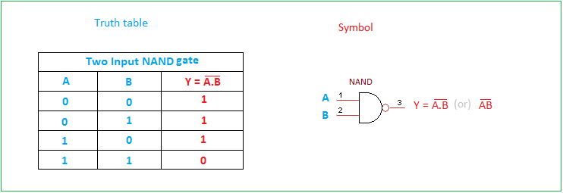

1. **AND GATE:**

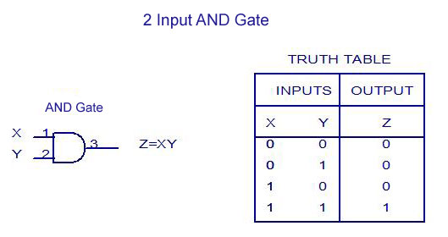

**Roll no : 1900321290050 Date:07-09-2020 page no:02**

**Practical Name : Design Basic Logic Gates Using Virtual Lab**

1. **OR GATE:**

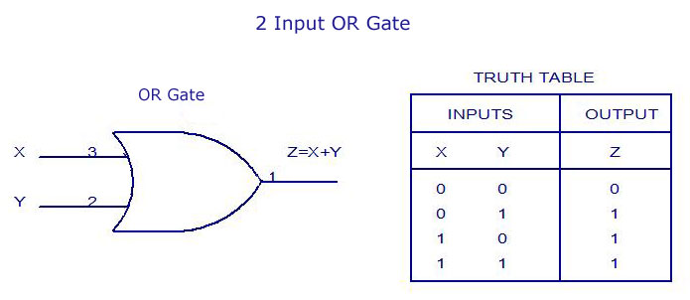

1. **NOR GATE:**

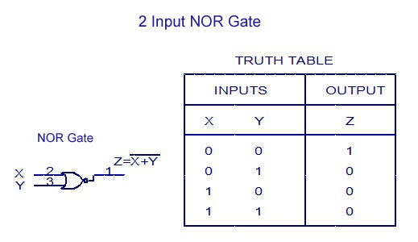

1. **XOR GATE:**

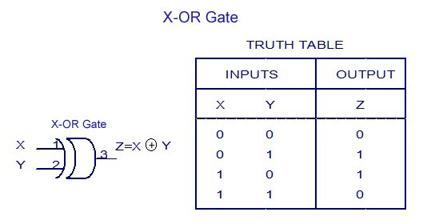

**Roll no : 1900321290050 Date:07-09-2020 page no:03**

**Practical Name : Design Basic Logic Gates Using Virtual Lab**

**6. NOT GATE:**

